History of India
in

India
Also known as: Bhārat, Bhāratavarsha, Republic of India

Philip B. CalkinsAll

Britannica Editors

Apr. 22, 2026 •History
Britannica AI
Ask Anything
The Indian subcontinent, the great landmass of South Asia, is the home of one of the world’s oldest and most influential civilizations. In this article, the subcontinent, which for historical purposes is usually called simply “India,” is understood to comprise the areas of not only the present-day Republic of India (free from British rule since August 15, 1947, celebrated as the country’s Independence Day) but also the republics of Pakistan (partitioned from India in 1947) and Bangladesh (which formed the eastern part of Pakistan until its independence in 1971). For the histories of these latter two countries since their creation, see Pakistan and Bangladesh.

News •
Voting begins in India's West Bengal state after a national voter list purge • Apr. 23, 2026, 12:25 AM ET (AP)
Since early times the Indian subcontinent appears to have provided an attractive habitat for human occupation. Toward the south it is effectively sheltered by wide expanses of ocean, which tended to isolate it culturally in ancient times, while to the north it is protected by the massive ranges of the Himalayas, which also sheltered it from the Arctic winds and the air currents of Central Asia. Only in the northwest and northeast is there easier access by land, and it was through those two sectors that most of the early contacts with the outside world took place.
Within the framework of hills and mountains represented by the Indo-Iranian borderlands on the west, the Indo-Myanmar borderlands in the east, and the Himalayas to the north, the subcontinent may in broadest terms be divided into two major divisions: in the north, the basins of the Indus and Ganges (Ganga) rivers (the Indo-Gangetic Plain) and, to the south, the block of Archean rocks that forms the Deccan plateau region. The expansive alluvial plain of the river basins provided the environment and focus for the rise of two great phases of city life: the civilization of the Indus valley, known as the Indus civilization, during the 3rd millennium bce; and, during the 1st millennium bce, that of the Ganges. To the south of this zone, and separating it from the peninsula proper, is a belt of hills and forests, running generally from west to east and to this day largely inhabited by tribal people. This belt has played mainly a negative role throughout Indian history in that it remained relatively thinly populated and did not form the focal point of any of the principal regional cultural developments of South Asia. However, it is traversed by various routes linking the more-attractive areas north and south of it. The Narmada (Narbada) River flows through this belt toward the west, mostly along the Vindhya Range, which has long been regarded as the symbolic boundary between northern and southern India.
The northern parts of India represent a series of contrasting regions, each with its own distinctive cultural history and its own distinctive population. In the northwest the valleys of the Baluchistan uplands (now largely in Balochistan, Pakistan) are a low-rainfall area, producing mainly wheat and barley and having a low density of population. Its residents, mainly tribal people, are in many respects closely akin to their Iranian neighbors. The adjacent Indus plains are also an area of extremely low rainfall, but the annual flooding of the river in ancient times and the exploitation of its waters by canal irrigation in the modern period have enhanced agricultural productivity, and the population is correspondingly denser than that of Baluchistan. The Indus valley may be divided into three parts: in the north are the plains of the five tributary rivers of the Punjab (Persian: Panjāb, “Five Waters”); in the center the consolidated waters of the Indus and its tributaries flow through the alluvial plains of Sind; and in the south the waters pass naturally into the Indus delta. East of the latter is the Great Indian Desert, also called the Thar Desert, which is in turn bounded on the east by a hill system known as the Aravali Range, the northernmost extent of the Deccan plateau region. Beyond them is the hilly region of Rajasthan and the Malwa Plateau. To the south is the Kathiawar Peninsula, forming both geographically and culturally an extension of Rajasthan. All of these regions have a relatively denser population than the preceding group, but for topographical reasons they have tended to be somewhat isolated, at least during historical times.
East of the Punjab and Rajasthan, northern India develops into a series of belts running broadly west to east and following the line of the foothills of the Himalayan ranges in the north. The southern belt consists of a hilly, forested area broken by the numerous escarpments in close association with the Vindhya Range, including the Bhander, Rewa, and Kaimur plateaus. Between the hills of central India and the Himalayas lies the Ganges River valley proper, constituting an area of high-density population, moderate rainfall, and high agricultural productivity. Archaeology suggests that, from the beginning of the 1st millennium bce, rice cultivation has played a large part in supporting this population. The Ganges valley divides into three major parts: to the west is the Ganges-Yamuna Doab (the land area that is formed by the confluence of the two rivers); east of the confluence lies the middle Ganges valley, in which population tends to increase and cultivation of rice predominates; and to the southeast lies the extensive delta of the combined Ganges and Brahmaputra rivers. The Brahmaputra flows from the northeast, rising from the Tibetan Himalayas and emerging from the mountains into the Assam valley, being bounded on the east by the Patkai Bum Range and the Naga Hills and on the south by the Mikir, Khasi, Jaintia, and Garo hills. There is plenty of evidence that influences reached India from the northeast in ancient times, even if they are less prominent than those that arrived from the northwest.
Along the Deccan plateau there is a gradual eastward declivity, which dispenses its major river systems—the Mahanadi, Godavari, Krishna, and Kaveri (Cauvery)—into the Bay of Bengal. Rising some 3,000 feet (1,000 meters) or more along the western edge of the Deccan, the escarpment known as the Western Ghats traps the moisture of winds from the Arabian Sea, most notably during the southwest monsoon, creating a tropical monsoon climate along the narrow western littoral and depriving the Deccan of significant precipitation. The absence of snowpack in the south Indian uplands makes the region dependent entirely on rainfall for its streamflow. The arrival of the southwest monsoon in June is thus a pivotal annual event in peninsular culture.

State in India
State | Population (2011 Census)
Uttar Pradesh | 199,812,341
Maharashtra | 112,374,333
Bihar | 104,099,452
West Bengal | 91,276,115
Madhya Pradesh | 72,626,809
Tamil Nadu | 72,147,030
Rajasthan | 68,548,437
Karnataka | 61,095,297
Gujarat | 60,439,692
Andhra Pradesh | 49,577,103
Odisha | 41,974,218
Telangana | ~35,193,978*
Kerala | 33,406,061
Jharkhand | 32,988,134
Assam | 31,205,576
Punjab | 27,743,338
Chhattisgarh | 25,545,198
Haryana | 25,351,462
Uttarakhand | 10,086,292
Himachal Pradesh | 6,864,602
Tripura | 3,673,917
Meghalaya | 2,966,889
Manipur | 2,855,794
Nagaland | 1,978,502
Goa | 1,458,545
Arunachal Pradesh | 1,383,727
Mizoram | 1,097,206
Sikkim | 610,577

India from the Paleolithic Period to the decline of the Indus civilization
The earliest periods of Indian history are known only through reconstructions from archaeological evidence. Since the late 20th century, much new data has emerged, allowing a far fuller reconstruction than was formerly possible. This section will discuss five major periods: (1) the early prehistoric period (before the 8th millennium bce), (2) the period of the prehistoric agriculturalists and pastoralists (approximately the 8th to the mid-4th millennium bce), (3) the Early Indus, or Early Harappan, Period (so named for the excavated city of Harappa in eastern Pakistan), witnessing the emergence of the first cities in the Indus River system (c. 3500–2600 bce), (4) the Indus, or Harappan, civilization (c. 2600–2000 bce, or perhaps ending as late as 1750 bce), and (5) the Post-Urban Period, which follows the Indus civilization and precedes the rise of cities in northern India during the second quarter of the 1st millennium bce (c. 1750–750 bce).
The materials available for a reconstruction of the history of India prior to the 3rd century bce are almost entirely the products of archaeological research. Traditional and textual sources, transmitted orally for many centuries, are available from the closing centuries of the 2nd millennium bce, but their use depends largely on the extent to which any passage can be dated or associated with archaeological evidence. For the rise of civilization in the Indus valley and for contemporary events in other parts of the subcontinent, the evidence of archaeology is still the principal source of information. Even when it becomes possible to read the short inscriptions of the Harappan seals, it is unlikely that they will provide much information to supplement other sources. In those circumstances it is necessary to approach the early history of India largely through the eyes of the archaeologists, and it will be wise to retain a balance between an objective assessment of archaeological data and its synthetic interpretation.

The early prehistoric period
In the mid-19th century, archaeologists in southern India identified hand axes comparable to those of Stone Age Europe. For nearly a century thereafter, evaluation of a burgeoning body of evidence consisted in the attempt to correlate Indian chronologies with the well-documented European and Mediterranean chronologies. As the vast majority of early finds were from surface sites, they long remained without precise dates or cultural contexts. More recently, however, the excavation of numerous cave and dune sites has yielded artifacts in association with organic material that can be dated using the carbon-14 method, and the techniques of thermoluminescent and paleomagnetic analysis now permit dating of pottery fragments and other inorganic materials. Research beginning in the late 20th century has focused on the unique environment of the subcontinent as the context for a cultural evolution analogous to, but not uniform with, that of other regions. Increasing understanding of plate tectonics, to cite one development, has greatly advanced this endeavor.
Most outlines of Indian prehistory have employed nomenclature once thought to reflect a worldwide sequence of human cultural evolution. The European concept of the Old Stone Age, or Paleolithic Period (comprising Lower, Middle, and Upper stages), remains useful with regard to South Asia in identifying levels of technology, apart from any universal time line. Similarly, what has been called the Indian Mesolithic Period (Middle Stone Age) corresponds in general typological terms to that of Europe. For the subsequent periods, the designations Neolithic Period (New Stone Age) and Chalcolithic Age (Copper-Stone Age) also are applied, but increasingly, as archaeology has yielded more-detailed cultural profiles for those periods, scholars have come to emphasize the subsistence bases of early societies—e.g., hunting and gathering, pastoralism, and agriculture. The terms Early Harappan and Harappan (from the site where remains of a major city of the Indus civilization were discovered in 1921) are used primarily in a chronological way but also loosely in a cultural sense, relating respectively to periods or cultures that preceded the appearance of city life in the Indus valley and to the Indus civilization itself.

The Indian Paleolithic
The oldest artifacts yet found on the subcontinent, marking what may be called the beginning of the Indian Lower Paleolithic, come from the western end of the Shiwalik Range, near Rawalpindi in northern Pakistan. These quartzite pebble tools and flakes date to about two million years ago, according to paleomagnetic analysis, and represent a pre-hand-ax industry of a type that appears to have persisted for an extensive period thereafter. The artifacts are associated with extremely rich sedimentary evidence and fossil fauna, but thus far no correlative hominin (i.e., members of the human lineage) remains have been found. In the same region the earliest hand axes (of the type commonly associated with Acheulean industry) have been dated paleomagnetically to about 500,000 years ago.
The Great Indian Desert, straddling what is now the southern half of the India-Pakistan border, supplied significant archaeological materials in the late 20th century. Hand axes found at Didwana, Rajasthan, similar to those from the Shiwalik Range, yield slightly younger dates of about 400,000 years ago. Examination of the desert soil strata and other evidence has revealed a correlation between prevailing climates and the successive levels of technology that constitute the Paleolithic. For example, a prolonged humid phase, as attested by reddish brown soil with a deep profile, appears to have commenced some 140,000 years ago and lasted until about 25,000 years ago, roughly the extent of the Middle Paleolithic Period. During that time the area of the present desert provided a rich environment for hunting. The Rohri Hills, located at the Indus River margins of the desert, contain a group of sites associated with sources of chert, a type of stone that is a principal raw material for making tools and weapons. Evidence surrounding these chert bands—in an alluvial plain otherwise largely devoid of stone—suggests their development as a major factory center during the Middle Paleolithic. The transition in this same region to a drier climate during the period from about 40,000 to about 25,000 years ago coincides with the onset of the Upper Paleolithic, which lasted until about 15,000 years ago. The basic innovation marking this stage is the production of parallel-sided blades from a prepared core. Also, tools of the Upper Paleolithic exhibit adaptations for working particular materials, such as leather, wood, and bone. The earliest rock paintings yet discovered in the region date to the Upper Paleolithic.
Other important Paleolithic sites that have been excavated include those at Hunsgi in Karnataka state, at Sanghao cave in North-West Frontier Province, Pakistan, and in the Vindhya Range separating the Ganges basin from the Deccan plateau. At the latter, local workers readily identified a weathered Upper Paleolithic limestone carving as a representation of a mother goddess.

Mesolithic hunters
The progressive diminution in the size of stone artifacts that began in the Middle Paleolithic reached its climax in the small parallel-sided blades and microliths of what has been called the Indian Mesolithic. A great proliferation of Mesolithic cultures is evident throughout India, although they are known almost exclusively from surface collections of tools. Cultures of this period exhibited a wide variety of subsistence patterns, including hunting and gathering, fishing, and, at least for part of the period, some herding and small-scale agriculture. It may be inferred from numerous examples that hunting cultures frequently coexisted and interacted with agricultural and pastoral communities. These relationships must have continually varied from region to region as a result of environmental and other factors. Strikingly, such patterns of interaction persisted in the subcontinent throughout the remainder of the prehistoric period and long into the historic, with vestiges still discernible in some areas in the 20th century.
Thus, chronologically, the Mesolithic cultures cover an enormous span. In Sri Lanka several Mesolithic sites have been dated to as early as about 30,000 years ago, the oldest yet recorded for the period in South Asia. At the other end of the subcontinent, in caves of the Hindu Kush in northern Afghanistan, evidence of occupation dating to between 15,000 and 10,000 bce represents the Epipaleolithic Stage, which may be considered to fall within the Mesolithic. The domestication of sheep and goats is thought to have begun in this region and period.
Many of the caves and rock shelters of central India contain rock paintings depicting a variety of subjects, including game animals and such human activities as hunting, honey collecting, and dancing. This art appears to have developed from Upper Paleolithic precursors and reveals much about life in the period. Along with the art have come increasingly clear indications that some of the caves were sites of religious activity.

The earliest agriculturalists and pastoralists

Neolithic agriculture in the Indus valley and Baluchistan
The Indo-Iranian borderlands form the eastern extension of the Iranian plateau and in some ways mirror the environment of the Fertile Crescent (the arc of agricultural lands extending from the Tigris-Euphrates river system to the Nile valley) in the Middle East. Across the plateau, lines of communication existed from early antiquity, which would suggest a broad parallelism of developments at both the eastern and western extremities. During the late 20th century, knowledge of early settlements on the borders of the Indus system and Baluchistan was revolutionized by excavations at Mehrgarh and elsewhere.
The group of sites at Mehrgarh provides evidence of some five or six thousand years of occupation comprising two major periods, the first from the 8th through the 6th millennium bce and the second from the 5th through the 4th (and possibly the 3rd) millennium. The earliest evidence occurs in a mound 23 feet (7 meters) deep discovered beneath massive alluvial deposits. Two subphases of Period I are apparent from the mound artifacts.
Phase IA, dating to the 8th–7th millennium bce, was an aceramic (i.e., lacking pottery) Neolithic occupation. The main tools were stone blades, including lunates and triangles, some probably mounted in wooden hafts with bitumen mastic; a relatively small number of ground stone axes have been found. Domestication of wheat and barley apparently reached the area sometime during this phase, as did that of sheep and goats, although the preponderance of gazelle bones among the animal remains suggests continued dependence on hunting. Houses of mud brick date from the beginning of this phase and continue throughout the occupation. Accompaniments to the simple burial of human remains included shell or stone-bead necklaces, baskets, and occasionally young caprids (both sheep and goats) slaughtered for the purpose.
Phase 1B, dating to the 7th–6th millennium, is characterized by the emergence of pottery and improvements in agriculture. By the beginning of Phase 1B, cattle (apparently Bos indicus, the Indian humped variety) had come to predominate over game animals, as well as over sheep and goats. A new type of building, the small regular compartments of which identify it almost certainly as a granary, first appeared during this phase and became prevalent in Period II, indicating the frequent occurrence of crop surpluses. Burial took a more elaborate form—a funerary chamber was dug at one end of a pit, and, after inhumation, the chamber was sealed by a mud brick wall. From the latter phase of Period I also come the first small, hand-modeled female figurines of unburned clay.
The Period I evidence at Mehrgarh provides a clear picture of an early agricultural settlement exhibiting domestic architecture and a variety of well-established crafts. The use of seashells and of various semiprecious stones, including turquoise and lapis lazuli, indicates the existence of trade networks extending from the coast and perhaps also from Central Asia.
Striking changes characterize Period II. It appears that some major tectonic event took place at the beginning of the period (c. 5500 bce), causing the deposition of great quantities of silt on the plain, almost completely burying the original mound at Mehrgarh. Nearly all features of the earlier culture persisted, though in altered form. There was an increase in the use of pottery. The granary structures proliferated, sometimes on a larger scale. The remains of several massive brick walls and platforms suggest something approaching monumental architecture. Evidence appears of several new crafts, including the first examples of the use of copper and ivory. The area of the settlement appears to have grown to accommodate an increasing population.
While the settlement at Mehrgarh merits extensive consideration, it should not be perceived as a unique site. There are indications (not yet fully explored) that other equally early sites may exist in other parts of Baluchistan and elsewhere on the Indo-Iranian borderlands.
In the northern parts of the Indus system, the earliest known settlements are substantially later than Mehrgarh. For example, at Sarai Khola (near the ruins of Taxila in the Pakistan Punjab) the earliest occupation dates from the end of the 4th millennium and clearly represents a tradition quite distinct from that of contemporary Sind or Balochistan, with ground stone axes and plain burnished red-brown pottery. The same is the case at Burzahom in the Vale of Kashmir, where deep pit dwellings are associated with ground stone axes, bone tools, and gray burnished pottery. Evidence of the “aceramic Neolithic” stage is reported at Gufkral, another site in the Kashmir region, which has been dated by radiocarbon to the 3rd millennium and later.

Developments in the Ganges basin
In the hills to the south of the Ganges (Ganga) valley, a group of sites has been assigned to the “Vindhya Neolithic”; for at least one of these, Koldihwa, dates as early as the 7th millennium have been reported. The sites contain circular huts made of timber posts and thatch; associated implements and vessels include stone blades, ground stone axes, bone tools, and crude handmade pottery, often bearing the marks of cords or baskets used in shaping the clay. In one case a small cattle pen has been excavated. Rice husks occur, though whether from wild or cultivated varieties remains to be determined. There exists considerable uncertainty about the chronology of these settlements; very few radiocarbon dates penetrate further than the 2nd millennium.

Earliest settlements in peninsular India
The earliest dates recorded for settlements in peninsular India belong to the opening centuries of the 3rd millennium. A pastoral character dominates the evidence. In the northern parts of Karnataka, the nucleus from which stone-ax-using pastoralists appear to have spread to many parts of the southern peninsula has been located. The earliest radiocarbon dates obtained in this area are from ash mounds formed by the burning on these sites of great masses of cow dung inside cattle pens. These indicate that the first settlers were seminomadic and that they had large herds of Brahman (zebu) cattle. The earliest known settlements, which were located at Kodekal and Utnur, date to about 2900 bce. Other important sites are Brahmagiri and Tekkalkota in Karnataka and Utnur and Nagarajunikonda in Andhra Pradesh. At Tekkalkota three gold ornaments were excavated, indicating exploitation of local ore deposits, but no other metal objects have been found, suggesting a relative scarcity of metals. These early sites produced distinctive burnished gray pottery, smaller quantities of black-on-red painted pottery, stone axes, and bone points, and in some instances evidence of a stone-blade industry. The axes have a generally oval section and triangular form with pointed butts. Among bone remains, those of cattle are in the majority, while those of sheep or goats are also present. Other settlements have been excavated in recent years in this region, but so far they have produced dates from the 2nd millennium, suggesting that the culture continued with little change for many centuries. Stone axes of a generally similar form have been found widely throughout the southern peninsula and may be taken as indications of the spread of pastoralists throughout the region during the 2nd millennium bce.

Earliest settlements in eastern India
Archaeologists have long postulated the existence of Neolithic settlements in the eastern border regions of South Asia on the basis of widespread collections of ground stone axes and adzes, often of distinctive forms, comparable to those of Southeast Asia and south China. There is, however, little substantial evidence for the date of these collections or for the culture of the people who made them. Excavations at one site, Sarutaru, near the city of Guwahati, revealed stone axes and shouldered celts (one of the distinctive tool types of the Neolithic) in association with cord- or basket-marked pottery.

The rise of urbanism in the Indus valley
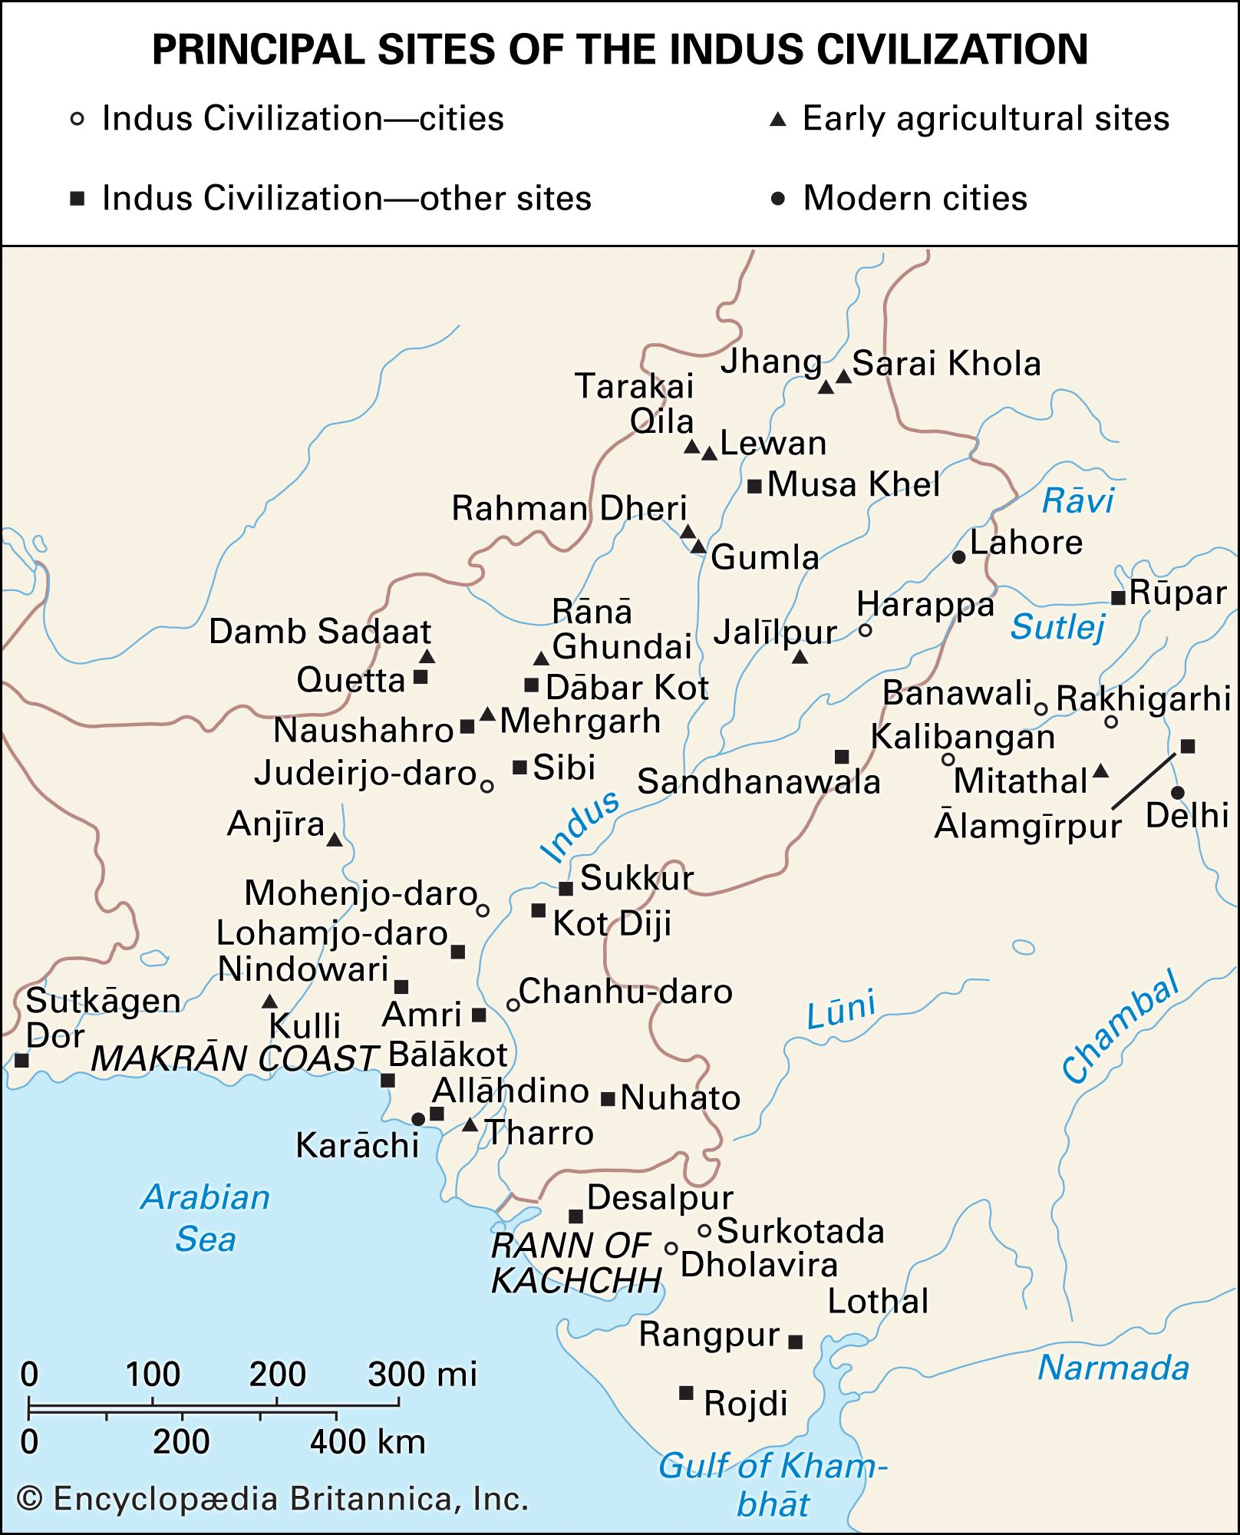
Principal sites of the Indus civilization
From about 5000 bce, increasing numbers of settlements began to appear throughout the Indo-Iranian borderlands. These, as far as can be judged, were village communities of settled agriculturalists, employing common means of subsistence in the cultivation of wheat, barley, and other crops and in the keeping of cattle, sheep, and goats; there was a broadly common level of technology based on the use of stone for some artifacts and copper and bronze for others. Comparison and contrast of the high-quality painted pottery of the period suggest distinct groupings among the communities.
At a somewhat later date, probably toward the middle of the 4th millennium bce, agricultural settlements began to spread more widely in the Indus valley itself. The earliest of these provide clear links with the cultures along or beyond the western margins of the Indus valley. In the course of time, a remarkable change took place in the form of the Indus settlements, suggesting that some kind of closer interaction was developing, often over considerable distances, and that a process of convergence was under way. This continued for approximately 500 years and can now be identified as marking a transition toward the full urban society that emerged at Harappa and similar sites about 2600 bce. For this reason, this stage has been named the Early Harappan, or Early Indus, culture.

Extent and chronology of Early Harappan culture
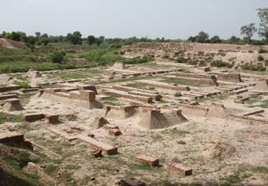
Harappa ruinsRuins of the ancient settlement of Harappa in Punjab, Pakistan.
It is now clear that sites assignable to the Early Harappan Period extend over an immense area: from the Indus delta in the south, southeastward into Saurashtra; up the Indus valley to western Punjab in the northwest; eastward past Harappa to the Bahawalpur region of Pakistan; and, in the northeast, into the Indian states of Punjab and Haryana. In short, the area of the Early Harappan culture was nearly coextensive with that of the mature Indus civilization.
Radiocarbon dating of artifacts from a number of the excavated sites provides a fairly consistent chronological picture. The Early Harappan Period began in the mid-4th millennium bce and continued until the mid-3rd millennium, when the mature Indus civilization displaced it in many regions. In some regions, notably in Punjab, the mature urban style seems never to have been fully established, and in these areas the Early Harappan style continued with little or no outward sign of mature Harappan contact until about 2000 bce.

Principal sites
One of the most significant features of the Early Harappan settlements is the evidence for a hierarchy among the sites, culminating in a number of substantial walled towns. The first site to be recognized as belonging to the Early Harappan Period was Amri in 1929. In 1948 the British archaeologist Sir Mortimer Wheeler discovered a small deposit of pottery stratified below the remains of the mature Indus city at Harappa. The next site to be excavated with a view to uncovering the Early Harappan Period was Kot Diji (in present-day Sind province, Pakistan). A stone rubble wall surrounded this settlement, which appears to date to about 3000 bce. An even earlier example is Rehman Dheri, near Dera Ismail Khan, which appears to have achieved its walled status during the last centuries of the 4th millennium. There the roughly rectangular, grid-patterned settlement was surrounded by a massive wall of mud brick. Early Harappan Kalibangan (Kali Banga) in Rajasthan resembled Rehman Dheri in form. It later served as the basis for an expanded settlement of the mature Indus civilization. Still farther east in the eastern Punjab and in Haryana are many other Early Harappan sites. Among them several have been excavated, notably Banawali and Mitathal. Another example of a walled settlement of the period is Tharro in southern Sind. This was probably originally a coastal site, although it is now many miles from the sea. There the surrounding wall and the extant traces of houses are of local stone.

Subsistence and technology
Many of the excavated sites mentioned above have yet to be fully studied and the findings published, and knowledge of the various features of the life and economy of their inhabitants remains somewhat scanty. All the evidence indicates that the subsistence base of Early Harappan economy remained much as it had already developed at Mehrgarh some two millennia earlier; cattle, sheep, and goats constituted the principal domestic animals, and wheat and barley formed the staple crops. From Kalibangan and several other sites in Bahawalpur and Punjab comes intriguing evidence concerning the use of the plow. At the former site, excavators discovered what appeared to be a plowed field surface preserved beneath buildings from the mature Indus period. The pattern of crisscrossed furrows was virtually identical to that still employed in the region, the wider furrows in one direction being used for taller crops, such as peas, and the narrow perpendicular rows being used for oilseed plants such as those of the genus Sesamum (sesame). From Banawali and sites in the desiccated Sarasvati River valley came terra-cotta models of plows, supporting the earlier interpretation of the field pattern.
The evidence for the various Early Harappan crafts and their products also calls for further publication and detail before a firm picture can be obtained. Thus far, only a small number of copper tools have been found, and little can yet be confirmed regarding their sources and manufacture. A number of the settlement sites lie far from any sources of stone, and thus the regular appearance of a stone-blade industry, producing small, plain or serrated blades from prepared stone cores, implies that the raw materials must have been imported, often from considerable distances. The same assumption applies to the larger stones employed as rubbers or grinders, but in the absence of detailed research, no firm conclusions are possible. Related evidence does indicate that some contemporary sites, such as Lewan and Tarakai Qila in the Bannu basin, were large-scale factories, producing many types of tools from carefully selected stones collected and brought in from neighboring areas. These same sites also appear to have been centers for the manufacture of beads of various semiprecious stones.

Culture and religion
It may be concluded on the basis of pottery decoration that major changes were taking place in the intellectual life of the whole region during the Early Harappan Period. At a number of sites the pottery bears a variety of incised or painted marks, some superficially resembling script. The significance of these marks is not clear, but most probably they represent owners’ marks, applied at the time of manufacture. Although it would be an exaggeration to regard these marks as actual writing, they suggest that the need for a script was beginning to arise.
Among the painted decorations found on the pottery, some appear to carry a distinctly religious symbolism. The clearest instance of this is in the widespread occurrence of the buffalo-head motif, characterized by elongated horns and in some cases sprouting pipal (Ficus religiosa) branches or other plant forms. These have been interpreted as representing a “buffalo deity.” A painted bowl from Lewan displays a pair of such heads, one a buffalo and the other a Bos indicus, each adorned with pipal foliage. Other devices from the painted pottery may also have religious significance, particularly the pipal leaves that occur as independent motifs. Other examples include fish forms and the fish-scale pattern that later appears as a common decoration on the mature Indus pottery. Throughout the region, evidence supports a “convergence” of form and decoration in anticipation of the more conservative Indus style.
The remains discussed above, considered collectively, suggest that four or five millennia of uninterrupted agricultural life in the Indus region set the stage for the final emergence of an indigenous Indus civilization about 2600 bce. It could also be argued, however, that the substantial Early Harappan walled towns constituted cities. Much research, excavation, and comparative analysis are required before this fertile and provocative period can be understood.

The Indus civilization

Character and significance
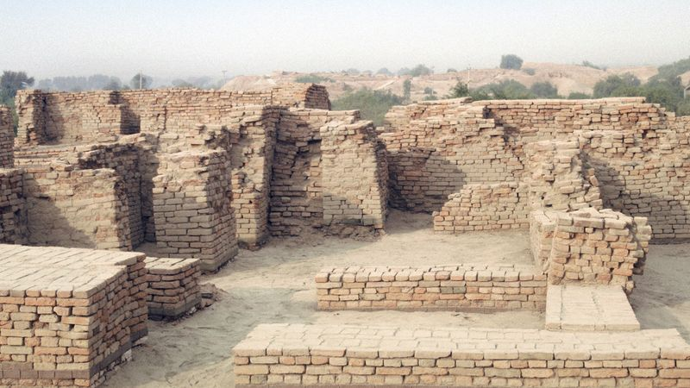
Language, Architecture, and Culture in the Indus River BasinLearn about the Indus civilization by watching this overview.
See all videos for this article
While the Indus (or Harappan) civilization may be considered the culmination of a long process indigenous to the Indus valley, a number of parallels exist between developments on the Indus River and the rise of civilization in Mesopotamia. It is striking to compare the Indus with this better-known and more fully documented region and to see how closely the two coincide with respect to the emergence of cities and of such major concomitants of civilization as writing, standardized weights and measures, and monumental architecture. Yet nearly all the earlier writers have sensed the Indian-ness of the civilization, even when they were largely unable to articulate it. Thus, historian V. Gordon Childe wrote that:
India confronts Egypt and Babylonia by the 3rd millennium with a thoroughly individual and independent civilization of her own, technically the peer of the rest. And plainly it is deeply rooted in Indian soil. The Indus civilization represents a very perfect adjustment of human life to a specific environment. And it has endured; it is already specifically Indian and forms the basis of modern Indian culture. (New Light on the Most Ancient East, 4th ed., 1952.)
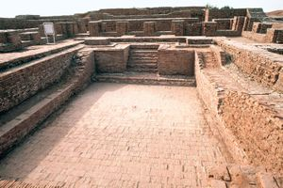
Mohenjo-daro: Great BathThe Great Bath, Mohenjo-daro, Sindh province, southeastern Pakistan.
The force of Childe’s words can be appreciated even without an examination of the Indus valley script found on seals; the attention paid to domestic bathrooms, the drains, and the Great Bath at Mohenjo-daro can all be compared to elements in the later Indian civilization. The bullock carts with a framed canopy, called ikkas, and boats are little changed to this day. The absence of pins and the love of bangles and of elaborate nose ornaments are all peculiarly South Asian. The religion of the Indus also is replete with suggestions of traits known from later India. The significance of the bull, the tiger, and the elephant; the composite animals; the seated yogi god of the seals; the tree spirits and the objects resembling the Shiva linga (a phallus symbolic of the god Shiva) of later times—all these are suggestive of enduring forms in later Indian civilization.
It is still impossible to do more than guess at the social organization or the political and administrative control implied by this vast area of cultural uniformity. The evidence of widespread trade in many commodities, the apparent uniformity of weights and measures, the common script, and the uniformity—almost common currency—of the seals all indicate some measure of political and economic control and point to the great cities Mohenjo-daro and Harappa as their centers. The presence of the great granaries on the citadel mounds in these cities and of the citadels themselves suggests—partly on the analogies of the cities of Mesopotamia—the existence of priest-kings, or at least a priestly oligarchy, that controlled the economy and civil government. The intellectual mechanism of this government and the striking degree of control implicit in it are still matters of speculation. Nor can scholars yet speak with any certainty regarding relations between the cities and surrounding villages. Much more research needs to be done, on many such topics, before the full character of the Indus civilization can be revealed.

Chronology
The first serious attempt at establishing a chronology for the Indus civilization relied on cross-dating with Mesopotamia. In this way, Cyril John Gadd cited the period of Sargon of Akkad (2334–2279 bce) and the subsequent Isin-Larsa Period (2017–1794 bce) as the time when trade between ancient India and Mesopotamia was at its height. Calibration of the ever-growing number of radiocarbon dates provides a reasonably consistent series from site to site. The broad picture thus obtained suggests that the mature Indus civilization emerged between 2600 and 2500 bce and continued in full glory to about 2000 bce. Thereafter the evidence is still somewhat unclear, but the late stage of the mature culture probably continued until about 1700 bce, by which time it is probably accurate to speak of the Post-Urban, or Post-Harappan, stage.

Extent
All the earlier writers have stressed the remarkable uniformity of the products of the Harappan civilization, and for this reason they provide a definite hallmark for its settlements. The more-recent evidence suggests that, if the outermost sites are joined by lines, the area enclosed will be a little less than about 500,000 square miles (1,300,000 square km)—considerably larger than present-day Pakistan—and if, as is generally inferred, this cultural uniformity coincided with some sort of political and administrative unity, the size of the resulting “empire” is truly vast. Within this area, several hundred sites have been identified, the great majority of which are on the plains of the Indus or its tributaries or on the now dry course of the ancient Saraswati River, which flowed south of the Sutlej River and then, perhaps, southward to the Indian Ocean, east of the main course of the Indus itself. Outside the Indus system a few sites occur on the Makran Coast, the westernmost of which is at Sutkagen Dor, near the present-day frontier with Iran. These sites were probably ports or trading posts, supporting the sea trade with the Persian Gulf, and were established in what otherwise remained a largely separate cultural region. The uplands of Baluchistan, while showing clear evidence of trade and contact with the Indus civilization, appear to have remained outside the direct Harappan rule.
To the east of the Indus delta, other coastal sites are found beyond the marshy salt flats of the Rann of Kachchh (Kutch) and in the interior of the Kathiawar Peninsula (Saurashtra). These include the estuarine trading post at Lothal on the Gulf of Khambhat (Cambay), as well as many other sites, some of which are major. West of the Indus River a number of important sites are situated on the alluvial Kachchhi desert region of Balochistan, Pakistan, toward Sibi and Quetta. East of the Indus system, toward the north, a number of sites occur right up to the edge of the Himalayan foothills, where at Alamgirpur, north of Delhi, the easternmost Harappan (or perhaps, more properly, Late Harappan) settlement has been discovered and partly excavated. If the area covered by these sites is compared with that of the Early Harappan settlements, it will be seen that there is an expansion in several directions, along the coast to both the west and the east and eastward through the Punjab toward the Ganges-Yamuna Doab.

Planning and architecture
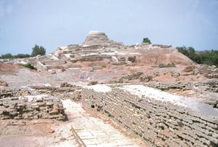
Mohenjo-daro ruinsStupalike stone tower, Mohenjo-daro, eastern Pakistan.
The Harappan sites range from extensive cities to small villages or outposts. The two largest are Mohenjo-daro and Harappa, each perhaps originally about a mile square in overall dimensions. Each shares a characteristic layout, oriented roughly north-south with a great fortified “citadel” mound to the west and a larger “lower city” to the east. A similar layout is also discernible in the somewhat smaller town of Kalibangan, and several other major settlements appear to have shared this scheme. Other major sites include Dholavira and Surkotada near the Rann of Kachchh; Nausharo Firoz in Balochistan, Pakistan; Shortughai in northern Afghanistan; Amri, Chanhu-daro, and Judeirjo-daro in Sind; and Sandhanawala in Bahawalpur. Among the smaller sites, special interest attaches to Lothal, where a number of unique and problematic features were discovered in excavations. Of all the sites, Harappa, Mohenjo-daro, Kalibangan, and Lothal have been most extensively excavated, and more can be said of their original layout and planning. Thus, they are considered in greater detail below.
At three of the excavated major sites, the citadel mound is on a north-south axis and about twice as long as it is broad. The lower city is laid out in a grid pattern of streets; at Kalibangan these were of regularly controlled widths, with the major streets running through, while the minor lanes were sometimes offset, creating different sizes of blocks. At all three sites the citadel was protected by a massive defensive wall of brick, which at Kalibangan was strengthened at intervals by square or rectangular bastions. At Kalibangan, traces of a somewhat less substantial wall around the lower town have also been discovered. In all three cases the city was situated near a river, although these courses are now extinct.
The most common building material at every site was brick, but the proportions of burned brick to unburned mud brick vary. Mohenjo-daro employs burned brick, perhaps because timber was more readily available, while mud brick was reserved for fillings and mass work. Kalibangan, on the other hand, reserved burned brick for bathrooms, wells, and drains. Most of the domestic architecture at Kalibangan was in mud brick. Brick was generally bonded in courses of alternate headers and stretchers—the so-called English bond. Stone was rarely, if ever, employed structurally. Timber was occasionally used as a lacing for brickwork, particularly in large-scale work such as the defenses or the granary at Mohenjo-daro. The common bricks were made in an open mold, but for special purposes sawed bricks were also employed. Timber was used for the universal flat roofs, and in some instances the sockets indicate square-cut beams with spans of as much as 14 feet (4.5 meters).
The houses were invariably entered from the side lanes, with the walls to the main streets presenting a blank brick facade broken only by the drainage chutes. Apart from domestic structures, a wide range of shops and craft workshops have been encountered, including potters’ kilns, dyers’ vats, and the shops of metalworkers, shell workers, and bead makers. There is surprisingly little evidence of public places of worship, although at Mohenjo-daro a number of possible temples were unearthed in the lower city, and other buildings of a ritual character were reported in the citadel. The size of houses varies considerably. At the one extreme are single-roomed barracks, with cooking and bathing areas formed within by partition walls, and at the other are large houses around a central courtyard or sometimes with a set of intersecting courtyards, each with its own adjoining rooms. Nearly all the larger houses had private wells. In many cases brick stairways led to what must have been upper stories or flat roofs. The bathrooms were usually indicated by the fine quality of the brickwork in the floor and by waste drains.

